ContentS
Navetti PricePoint
- Pricing with PricePoint-
1 Introduction 3
1.1 Overall description 3
2 Pricing Domain 4
2.1 Aftermarket Spare Parts Pricing 4
2.2 Price Waterfall 4
2.3 Pricing Methodologies 5
2.4 Why Pricing and setting the Price level is so important 6
2.5 Pricing Complexity 6
3 Navetti PricePoint 8
3.1 Management of Price Waterfall with PricePoint 9
3.2 Business Entities and Entity Structures 9
3.3 Price Types 10
3.3.1 Time dimension of prices 11
3.4 Management of Prices 11
3.4.1 Setting the price (pricing flow) 12
3.4.2 Price Revision Flow 14
3.5 Application Modules and Plugins 16
3.6 NAIS Integration 18
3.7 Document History 19
3.8 References 19

Introduction
This document is intended to be used as a general overview of the pricing domain, challenges and Navetti Price Point as a solution which is used to make the pricing process easy.

Overall description
Navetti PricePoint is a solution that offers complete support for the pricing process throughout the whole organisation. It is essential for global companies to have a distinct pricing process where the international reference price is created, so that this price further can be adjusted in line with local competitive situation for different groups of assortments on different markets.
PricePoint has a modular design, which means that the modules can either be used separately or in combination with other modules depending on the needs of the customer.

Pricing Domain

Aftermarket Spare Parts Pricing
Aftermarket is a secondary market that supplies accessories, spare parts, second-hand equipment, and other goods and services used in repair and maintenance. Ex. The automotive aftermarket is the secondary market of the automotive industry concerned with the manufacturing, remanufacturing, distribution, retailing and installation of all vehicle parts, chemicals, equipment and accessories, after the sale of the automobile by the original equipment manufacturer to the consumer.
Navetti Price Point is mainly focused on companies selling aftermarket spare parts, but not limited to this segment. There are clients like Zara, H&M, Ikea which are from the retail industry. The product supports implementation of pricing methodology for these types of companies too, but main focus is the aftermarket spare parts pricing.
They are selling consultancy in pricing, which they support with Price Point – tool for implementation of pricing methodologies and prices for articles.

Price Waterfall
Pocket Price Waterfall is a simple but powerful tool which shows how much revenue companies really keep from each of their transactions—helps them diagnose and capture opportunities in transaction pricing. The price waterfall brings visibility to this important issue.

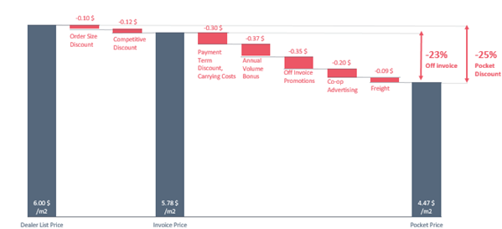
Figure 1 Pocket Price Waterfall
Pocket Price presents the revenues that are actually left in a company’s pocket from a transaction to cover costs and contribute to profit. Pocket price (not invoice price or list price) is the right measure of the pricing attractiveness of a transaction. Price Pocket is used to see the level of different price points and potential spots where savings can be made.
Ultimate goal – maximize the Pocket Price in each transaction to maximize profit level.

Pricing Methodologies
There are three main pricing strategies: cost-based, market-based and value-based pricing.
- Competitive pricing means setting prices relative to competitors. For example, a new neighborhood restaurant might use the prices of entrees at other restaurants in the area to inform pricing decisions. Companies may choose to set prices slightly below those offered by competitors to attract more customers. Competitive pricing can potentially result in a price war, in which competitors repeatedly slash prices in an attempt to undercut one another.
- Cost-based pricing is a strategy that uses the cost of production as a baseline to inform pricing decisions. Cost-based pricing is a relatively straightforward strategy since it doesn't take consumer demand or competition into account. Cost-based pricing is also called cost-plus or mark-up pricing and constitutes of using the cost as a base and then adding a standard mark-up to retrieve the final price.
- Setting prices based on the benefit or value consumers derive from products is called value pricing. In other words, value-based pricing seeks to set prices based on what consumers are willing to pay. A business pursuing value-based pricing might charge prices that are significantly higher than competitors if it believes its products are more valuable to consumers than those offered by competitors or if wishes to establish itself as a luxury brand.
Navetti PricePoint with its flexibility covers all pricing strategies and allows combination of the pricing of the items.


Figure 2 Example of cost vs. value based pricing: Cost Based - With the cost based pricing the price of the car reflects the cost (all parts included in the car) + Mark up. Value Based - In the value based pricing goes top-down , the price of the car is expressed with the value it brings to the customer (ex. Not only usage of it, but also status, security etc.)

Why Pricing and setting the Price level is so important
In order to increase the competiveness of a company there are three commonly used methods of interest; decrease of costs, increase the market share and/or adjust the prices. Adjustments of prices, also known as pricing strategy, aim’s to establish an optimum price in relation to profit maximization of the product or service sold.
It has been proven that an improvement in the pricing process has a clear advantage compared to cost cutting
There are different ways on how to increase the profit:
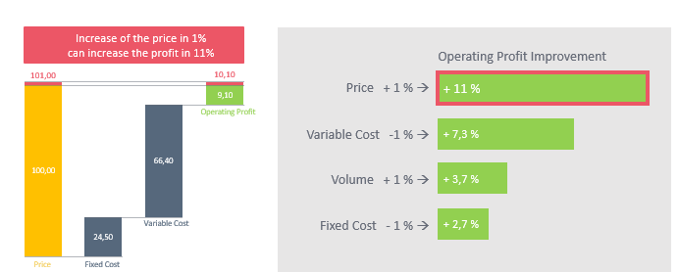
Figure 3Alternatives to increase profit
Figure 3 shows an example of how profit can be increased using different alternatives (lower costs/increase price/increase sales volume)
- Increase of only 1% in price without losing volume is far stronger leverage than lowering cost or increasing volume with the same percentage.
- Decrease in variable cost means increase of profit in 7.3%
- Lowering the fixed cost of 1% has impact on increasing the profit of 2.7%
- Increase of sales volume has 3.7% impact on profit increase

Pricing Complexity
Setting a price of a product can be very complex especially when it comes to selling the product internationally. In this case it may be necessary to set different prices for different markets considering different conditions that are influencing the price and which are required to be considered when setting the correct price level.
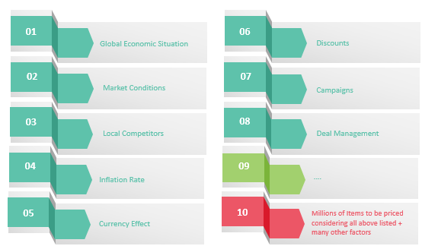
Figure 4 Price challenges and pricing complexity
All these factors (and many others) have influence on the price levels and need to be considered when setting the price level for an item.
See Figure 5 for effect of the exchange rate to the price level.
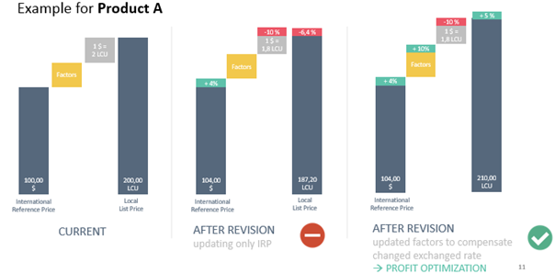
Figure 5 Take advantage of FX changes

Navetti PricePoint
Navetti PricePoint is a solution that offers complete support for the pricing process throughout the whole organization. It is essential for global companies to have a distinct pricing process where the international reference price is created, so that this price further can be adjusted in line with local competitive situation for different groups of assortments on different markets.
It enables implementation of the pricing strategy as well as evaluating the effect of the implemented strategy to the profit.
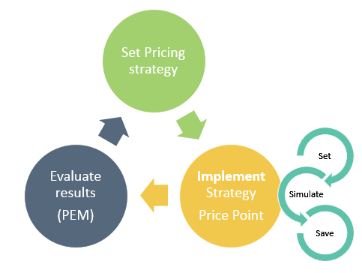
Figure 6 High Level pricing flow
With the latest version the following areas of the price waterfall are covered and enable the price managers to set optimal prices and maximize the profit with management of the following areas:
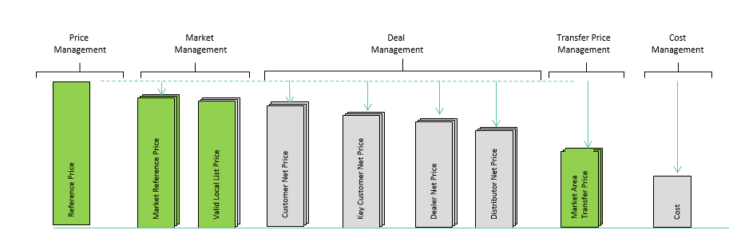
Figure 7 Price Waterfall covered aspects by PricePoint

Management of Price Waterfall with PricePoint
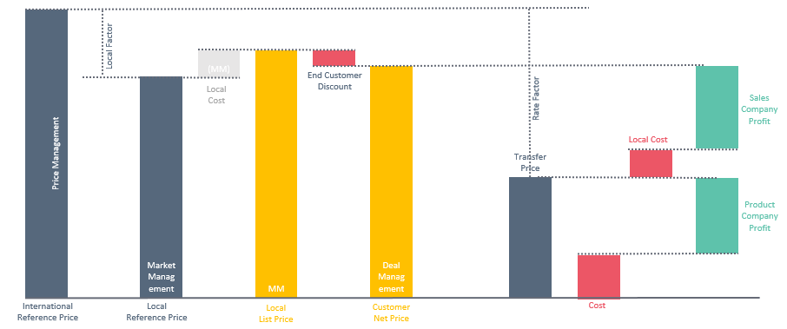
Figure 8 Price Waterfall with PricePoint
On Figure 8 is described a generic model of Price Waterfall incorporating some PricePoint methodology of pricing.
- Base Price * LF (Local Factor) = Local Base Price
- Local Base Price + Landed Cost (ex. Cost for transport) = Local List Price
- Local List Price – Customer Discount (special competitive discount, dealer discount, order size discount, cash discount, special extended terms, volume rebate etc) = Customer Net Price
- Base Price * RF (Rate Factor) = Transfer Price (cost for the CC unit)
- Transfer Price – Cost = Profit for the production company
- Base Price – (Transfer Price + Landed Cost) = Profit for customer center

Business Entities and Entity Structures
PricePoint allows management of different structures consisted of business entities, organizing entities in different groups and everything with a purpose of easing the price management.
PricePoint supports different types of business entities (Product company, sales company, dealer, supplier etc.)
Structures can be defined based on different business entity types or business entities can be organized in different groups (based on the type) or they can be organized in groups based on market where they belong. This way there is a great flexibility of setting and adjusting prices for different types of business entities for different regions.
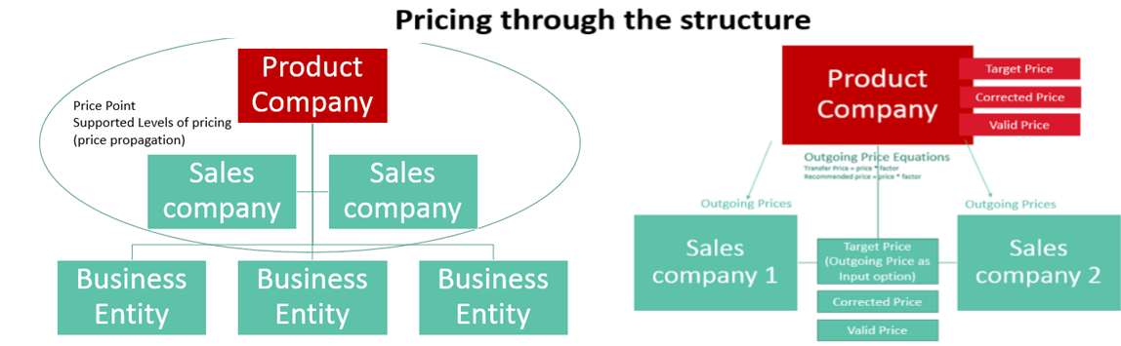
A very important thing to be mentioned is the sales channel. The sales channels define which Business Entity is buying from which Business entity. Currently PricePoint supports management of prices (sending prices) only between Product company and Sales Companies. Pricing process between the Sales companies and lower entities in the structure currently is not supported.

Price Types
PricePoint supports different price types and all meant from different purpose.
Price Type | Description | Example
Incoming fix | The value of this price type comes from external system and should not be changed through the system | Ex. Agreement price (10 available prices)
Incoming manageable | The value of this price type comes from external system, but can also be managed through application | (no price from this type is currently used in any logic, but sometimes cost can be set from this type)
Input | The value of this price type comes from external system and should not be changed through our system | Ex. Cost  Cost is an input refers to the expense made to purchase or produce the item.
Internal Calculated | Price type which cannot be changed manually but is only calculated by some predefined rule/formula | Ex. Target price, BOMValid1, BomValid2
Internal Managed | This is a price type which is internal and can be defined manually or set as a result of a process | Ex. Valid Price can be set via price point or can be calculated (ex. Increased by 10% in the revision process)
Outgoing | Outgoing prices are the prices which one business entity (sender) sends to the lower level business entity  (receiver). | Ex. Recommended and Transfer price where the product company calculates these based on some formulas and sends these prices to the sales companies. (22 available prices)
The price points from these price types are defined and calculated on Business Entity (BE) level. Business entities manage their own prices, but there are cases (like the outgoing prices for example) where the BE sets the rules for calculating the prices of another BE (receiver) and the receiver BE gets the prices.
In the example below and how clients are working:
- Product company sets equations and rules for calculating outgoing prices.
- The outgoing prices are calculated separately for each BE, and are used as input for calculating other prices from the Price Waterfall.

Time dimension of prices
It is important to say that the prices have time dimension meaning we have one price value for the price at time A and another value for that price at time B.
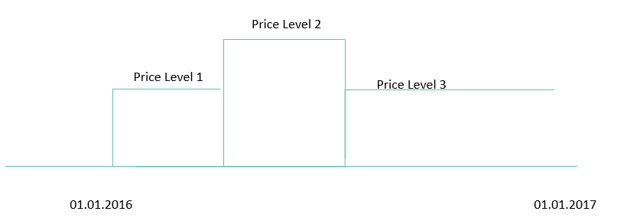
Figure 9 Time dimension of prices
System allows management of prices at different points in time.
It is not only the prices, but there are other item properties which have time dimension (ex. Whether the item will be included in the price list this period or next period).
Ex. Product A Valid Price value
Price Type | Value | Valid From | Valid To
Valid Price | 30 | 01.01.2016 | 01.03.2016
Valid Price | 35 | 01.03.2016 | 01.06.2016

Management of Prices
Generally, there are two flows for managing the prices in PricePoint:
- Setting the price
- Price revision

Setting the price (pricing flow)
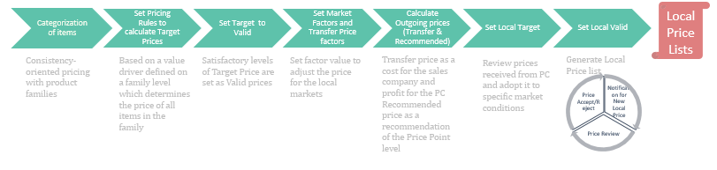
Figure 10 Pricing Flow
Step 1: Categorization of items (Groups Management)
The first step in the pricing is categorization of the item, where parts are categorized on price sensitivity and competition. The second categorization is done in the Price Management module which structures the spare part inventory to families and develops a price logic within these families according to the customers’ perceived value. A logical price structure can be created based on a single or several attributes, such as weight, that are the value drivers of the item. Another example can be viewed in Figure 11, where diameter is a value driver for bearings. Since the items within the families are priced based on their value drivers a homogenous pricing can be achieved, implying that value equivalence line can be plotted based on these value drivers. This also eases pricing of new components since they should be priced directly based on their family’s value drivers.
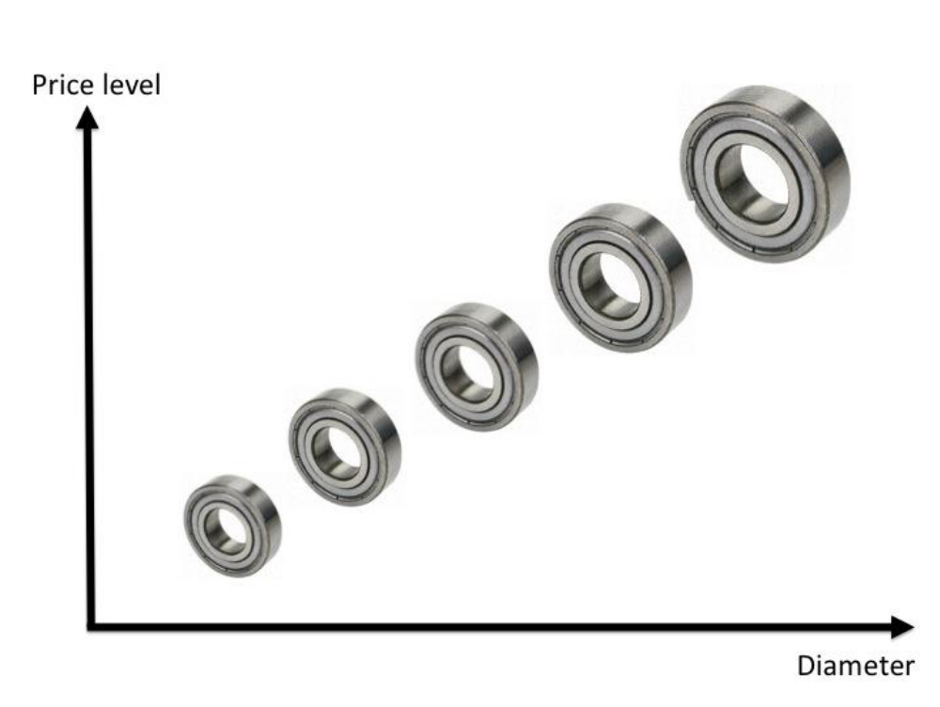
Figure 11 Categorizing/Pricing items based on diameter

Step 2: Setting Price Rule (Price Management – Price Rules)
PricePoint offers a very powerful functionality for management of rules for calculation of the Target Prices. With the possibility to use every item property to base the price on it (or use a mix of item properties), it is possible manage Target Price and define the most suitable method for a group of items. In addition, if offers the possibility to set conditions based on which the items from the groups will be filtered and set a specific rule only for sets of items. One groups of items can be priced based on different rule depending on conditions. At the end, the resulting Target price of the item can be limited by setting high and low limits of the price.
Ex. For the above items
We can set a rule that Price = Diameter * 100
With a Post Condition saying
- Min accepted price = cost + 10%
- Max accepted price = cost + 100%
every time the calculated price goes beyond the range, it will be limited with the specified min/max.
With this rule we can be sure that items with larger diameter will have higher price and also that the price will always cover the cost, but it cannot be very high, but limited as 100% higher than the cost.

Step 3: Set Target To Valid (Price Management – Price Rules)
After setting the Target Prices, if the level of the Target price is satisfactory, the price is set as valid and like that, the item is ready to be “sold” through the sales channels by that price (NOTE: this price is adjusted for specific markets).

Step 4: Set Market Factors and Transfer Price factors (Market Management)
As each Market has its own conditions (exchange rate fluctuations, competitors, uniqueness of the items on the market etc.), by setting factors for each separate market, the system allows adjustment of the price levels to the market conditions. This is done with setting factors that are used in the outgoing prices.
Example for outgoing prices are transfer and recommended.
Transfer price is the cost for the BE receiver (Sales company) and profit for the BE sender (product company).
Recommended price is the recommended price level for selling the specific item.

Step 5: Calculate Outgoing Prices (Market Management)
Outgoing prices are calculated based on the equations (rules) set by the product company.
Ex. Outgoing price 1 = Valid Price * Factor 1
Outgoing price 2 = Valid Price * Factor 2
(this is a basic equation. Clients are using different inputs (ex. Cost) and combination of different factors to calculate the outgoing prices).
Factors are used for adjustment of the Valid price (list price) of the Product company to the market conditions of the sales company.
The outgoing prices are calculated once the parameter of the outgoing prices equation is changed (ex. Valid price or factor as per above example)
The application offers a functionality for calculating the future outgoing prices (prices that the sales companies will be able to use as a base to prepare their next period (ex. Next year) price lists)
Calculation of the future outgoing prices takes into consideration future input parameters (future valid price, exchange rate, factor) in order to reflect the price in best way closest to the expected future conditions.

Step 6: Set Local Target (Price Management - General Pricing)
As said earlier, prices have local values (value is defined on BE level), so one item may have different price values from one price type in different business entities.
Product company sets its own Target Price rules on a group level and the Sales companies have the right and are setting their own levels of Target Prices.
Mainly on SC level as input for calculating the Target price are the outgoing prices calculated based on rule and prices from PC with factors adjustments.
Local Companies (sales companies) are using different functionality for setting rules for the Target price (General Pricing).
On this level, and with this functionality as the Target price is mainly calculated from prices inherited and defined by rules (strategy) from the PC, the Local company adds just a factor (or not) to additionally adjust the price and saves it. There is an option to auto copy this price as local valid price (price which is part of the sales company price list and used as official price for selling the items.

Step 7: Set Local Valid Price
Local Valid Price can be defined by a rule with general pricing where it will inherit the value of the Target price automatically, by accepting the price (outgoing or target) with the local launch manager or by setting manually value for it.
Local Launch Manager is a functionality which is used by some clients and which allows the Pricing Managers to make decide on whether to accept or reject the price suggested by the Product Company.
In the Local Launch Manager, the price manager can decide whether to accept the outgoing price from the PC and set is as Local Valid Price, reject it, or set the Target price as valid.
Each change of the Outgoing price from PC raises alert to the SC so that the price manager is informed on all changes

Price Revision Flow
Figure 12 Price Revision Flow

Once the prices are set, they are revised and adjusted on some regular periods (revision dates).
In the process of revision, the price managers are making adjustments to adopt the prices for the next period. With this process basically are made changes for some future period (Ex. In December 2015 through the revision process are made adjustments to prices which will be valid from 01.01.2016)
The revision process described here is a general one, where clients may have their own specific details (Steps included /excluded) from the one described here)

Step 1: Corrected Price Adjustment
Target price is the price defined by a pricing rule.
Valid price is the actual price of the item for a defined period of time.
The intention is the valid to reach the level of target.
Sometimes there is a great difference between these two prices and therefore the Corrected price is used as an intermediate price between these to. The purpose of this price is for the valid to reach the target price level step by step in order not to have drastic price changes for an item.

Step 2: Price Adjustment
The economy is influenced by many global and local factors. Prices need to reflect the changes. In each revision the prices are adjusted by some %. This same % is then included as a Price index in the Target Price rule.

Step 3: Kits Revisions
Kits are items which are consisted of other items. Ex. We have an item (wheel) and that item is consisted of different other items (ex. Tire; screws; wheel cover etc.). Kits have their own pricing logic, but the basic is that the sum of the price of the items which are part of the wheel, should not be lower than the wheel itself.
Changes of the prices of the items which are parts of the wheel, should change the price of the wheel itself. This should be covered in the revision process too.

Step 4: Price Index Adjustment
With the price adjustments (step 2); valid price is adjusted with some % reflecting local and global economic factors.
These changes should also be reflected in the Target Price rule. Price Index is used for that purpose. PricePoint offers a functionality which suggest some price indexes to adjust the Target Prices based on the Price adjustments made in step 2 of the revision process.

Step 5: Currency revision
The application manages exchange rates and uses conversion when calculating specific prices
NOTE: the application does not have fully implemented mechanism to always check and convert prices in different currencies. The use cases of current clients are covered and no need to have a mechanism implemented in each functionality (so far). Current clients expect to have prices from all price types in one currency in one BE and when sending prices (outgoing prices) to other business entities prices are converted to the currency of the receiver BE.

Step 6: Factors Adjustments
Factors are used to adjust prices on local markets. In each revision period factors need to be adjusted to reflect changes of the local market.

Step 7: Future Outgoing prices
Once all previous steps are done, price managers of the Product Company are generating the outgoing prices (local prices) that will be available for the next period for the local companies (Sales companies). These prices are generated in advanced to be able to check and see if some additional adjustments are needed.

Step 8: Local revisions
Once the Sales Companies receive outgoing prices they are using them to set and adjust their local target and valid prices.

Application Modules and Plugins

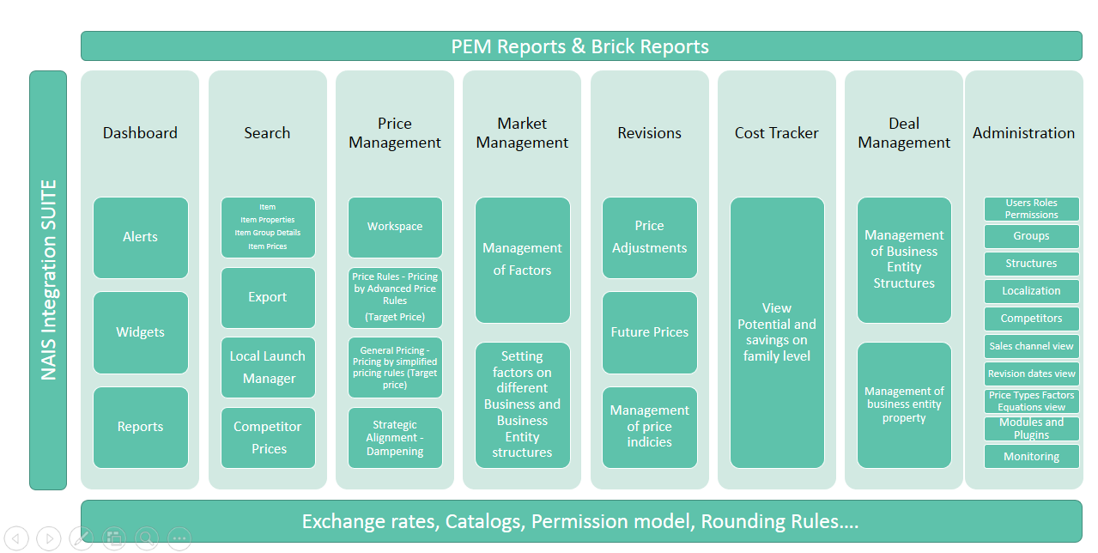
Figure 13 Application modules and plugins

Modular solution where clients can buy different modules based on their needs.
- Dashboard (alerts and reports) – used to give an overview reports with valuable information and alert for items to be categorized or priced
- Search Module (list of items with properties, search, export, competitor prices)
- Administration (management, configuration and applications settings) . NOTE: not all settings or application functionalities have UI for management. Some things can be configured only through DB (check more in Configuration guide.
- Price Management — for setting and optimizing international reference prices, global price lists and employing pricing rules defined by business users to enable value-based pricing.
- Market Management — for setting and optimizing local list prices, defining regional price corridors, and employing pricing rules defined by business users to account for specific market conditions (currency fluctuations, inflation and competitor landscape)
- Cost Tracker — for defining and maintaining key elements, figures for modelling cost to service
- Revisions – for managing revisions where on year/half year level the prices are revised and adjusted and outgoing prices are generated for the next period
- Deal Management – management of business entity structures and business entity properties (developed so far) with ultimate goal to manage different buying conditions, discounts for all transactions based on customer loyalty, segment, volume and other available factors.
- PEM (Performance Management) & Brick Reports provide logical, functional analysis of actual sales, monthly, annual sales comparisons, price and volume data, customer net price levels, market levels, volume analysis, family price and price history. You can edit and create reports to focus on specific areas, set up distribution lists.
More details on application functionalities can be found on Navetti’s Confluence
- Product Development (requirement specifications for functionalities)
- Application User Guide (application functionalities)
- Application Configuration Guide (guide on how and where some functionalities can be configured)
- PEM Reports (available reports and report functionalities)
- Apps (available brick reports)
NOTE: These links are from the latest version of the application (4.6.0.0). There will be different spaces for each new application version. Please check the latest version in order to get latest versions of these guides.

NAIS Integration
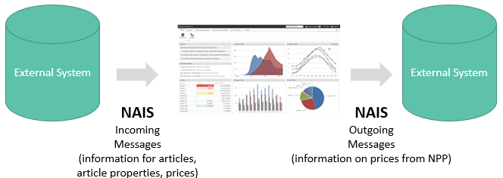
The Navetti Agile Integration Suite (NAIS) enables the possibility for the systems within a corporation to share information. In the process of integrating PricePoint as a pricing system in the companies, other systems (ex. Erp system) are exchanging information with PricePoint using NAIS (ex. Information on articles, properties, groups, prices etc.).

References
All documents (pages) listed below are located on Navetti’s Confluence system (https://services.navetti.com/confluence/). Some of them may be available without credentials, but some may require login.
Documents 1-4 refer to version 4.6.0.0

- Glossary
- Application User Guide (user guide for all application functionalities)
- Application Configuration Guide (guide on how and where some functionalities can be configured)
- Price Propagation details (propagation flow and limitations)
- Deployment Manual (step by step manual for application deployment)
- PEM Reports (available reports and report functionalities)
- Video tutorials

Document History
Edition: | Date: | Created by: | Description:
01 | 2016-06-24 | Biljana Trpkovska | Initial version

